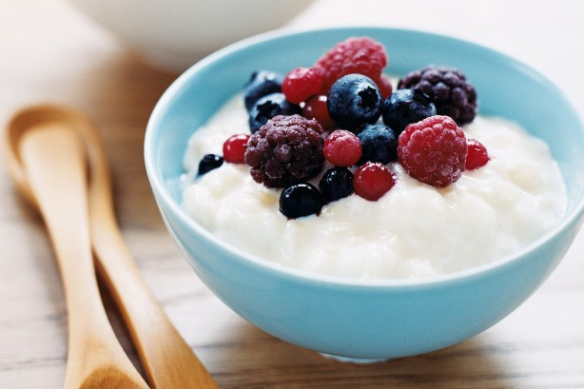Recipe card background

By Madeleine Wallace 8.4 Technology

Ingredients Method

1 cup (220g) medium White Rice 1. Boil water in a saucepan, add

2 tablespoons cornflour rice, cook, drain and rinse.

1 cup (250ml) milk 2. Combine rice and other

300ml thickened cream ingredients over medium-low

1 egg, beaten heat. Cook for 5 minutes,

1 teaspoon vanilla extract stirring, until thick and creamy.

Fresh berries, or fruit of choice. 3. Top with fruit and enjoy!

Creamy Rice Pudding