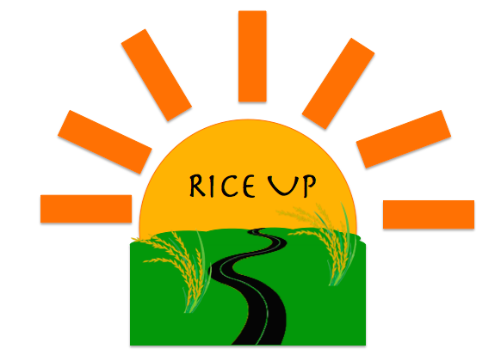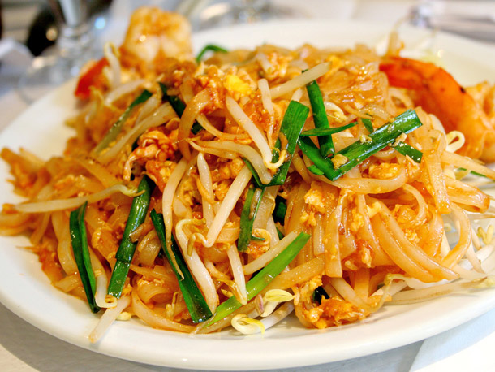Recipe card background

By Madeleine Wallace 8. Technology

Ingredients Method

100g dried thick noodles 1.Place noodles in a large heatproof

2 shallots bowl. Cover with boiling water,

2T lime juice remove when tender, drain.

2T chicken stock 2.Slice shallots. Combine lime juice,

1T fish sauce chicken stock, fish sauce and sugar.

1T brown sugar 3. Place frypan over medium heat.

½ Chicken breast Cook chicken until golden.

150g green beans 4. Remove chicken. Add beans, carrot

1 egg, beaten and shallots. add egg and cook.

½ carrot 5.Add noodles, sauce and

chicken. Enjoy!

Pad Thai