Ingredients Method

2 cups Brown Rice 1.Cook rice in boiling water until tender

Olive oil cooking spray 2. Drain and rinse. Place wok over

4 eggs, lightly beaten medium heat, spray with oil. Pour in

125g packet bacon egg, cook roll and chop.

1/2 teaspoon sesame oil 3. Add bacon and stir-fry until golden.

4 green onions, sliced 4. Add all other ingredients, stir-fry.

500g cooked prawns, 5. Enjoy!

1 cup frozen peas

2 tablespoons soy sauce

1 cup beansprouts

By Madeleine Wallace 8.4 Technology

Easy-Peasy Fried Rice

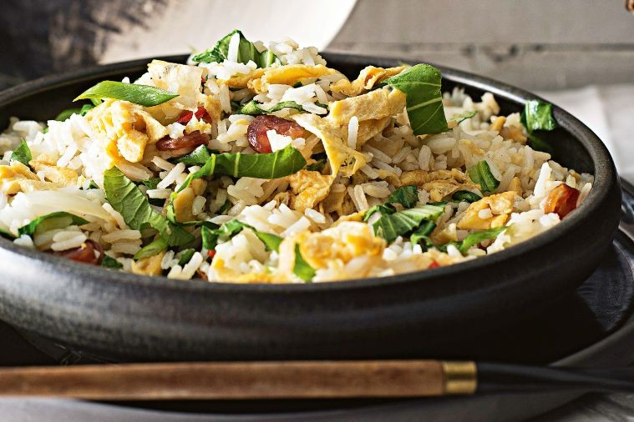

Recipe card background

