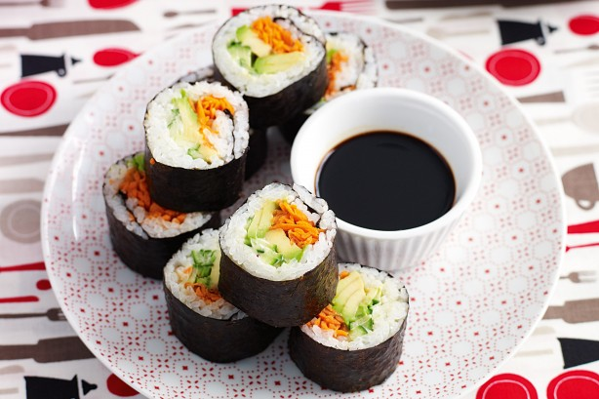Recipe card background

By Madeleine Wallace 8.4 Technology

Ingredients Method

* 1 1/2 cups Japanese Style Sushi Rice 1.Place rice in a saucepan with
* 2 tablespoons white vinegar boiling water. Cook for 12 minutes.
* 1 tablespoon caster sugar 2.Heat vinegar and sugar together
* 4 nori sheets in microwave for 30 seconds.
* 2 tablespoons egg mayonnaise 3. Place 1 nori sheet on a sushi
* 1 cucumber, cut into sticks mat. Fill with rice and other
* 1 medium avocado, sliced fillings, then roll.

1 medium carrot, grated 4. Enjoy!

Soy sauce, to serve

Japanese style Sushi